IFT 266 Introduction to Network Information Communication Technology (ICT)
Lab 6
Switch Configuration (Speed & Duplex)

After you complete each step, put an ‘x’ in the completed box

Part A: Sped and Duplex (Verification and Configuration)
- In Packet Tracer setup the following topology. You can use two generic switches, but you will need to add in some Gigabit ports to the switch. Use a crossover cable as the transmission media.

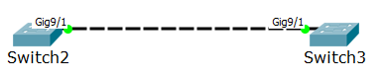

When adding the Gigabit ports, there are two modules that you can choose from based on copper or optical connectivity (s).
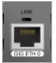
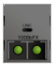
- PT-SWITCH-NM-1CGE - Single-port Cisco Gigabit Ethernet Network Module (part number PT-SWITCH-NM-1CGE) provides Gigabit Ethernet copper connectivity

- PT-SWITCH-NM-1FGE - Single-port Cisco Gigabit Ethernet Network Module (part number PT-SWITCH-NM-1FGE) provides Gigabit Ethernet optical connectivity

For this lab, we will use PT-SWITCH-NM-1CGE.


- The first aspect we will look in this lab is speed. How quickly do we want to send data between these switches? Open up the command line on either switch (as we have done in previous labs) and we will first check the status of the switch ports i.e. whether they are up and running.

- Execute the following the commands.
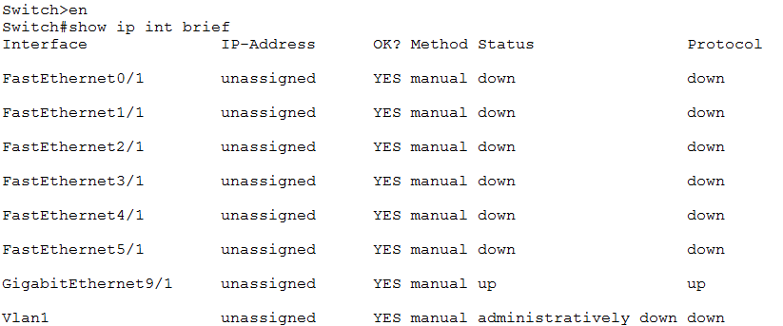

In lab 4 we mentioned that you can use various show commands to check the settings and configurations on the switch. The show ip int brief command will confirm that Gigabit port is up and running.

You can see that the port is ‘up’ and ‘up’. The status ‘up’ is Layer 1 while protocol ‘up’ is Layer 2. This shows we have a good connection to the other switch.

Follow-up Question
Can you run the show ip int brief command while in user mode? If no, why not?

- Now type the show interfaces command which will display among other things the speed and duplex used for that particular port i.e. in our case the gigabit port.

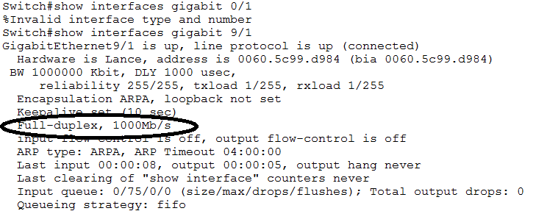

- Why not always set the max speed for a port?

A switch device may not support Gigabit links (only supports Fast Ethernet) so we can manually set a lower rate.

- To change the speed of a particular port, run the following commands

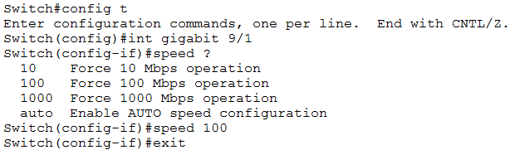

- Now run the show interfaces command to see the updated speed on the port

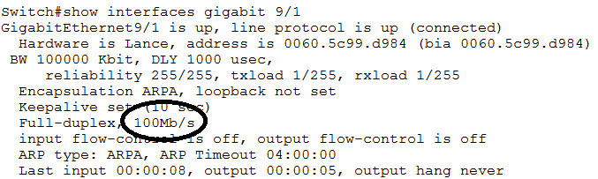

- We could change the speed on multiple ports by using the range command e.g. int range fa 0/1 – 3

- Remembering back to your IFT 166 days, we had different modes of duplex.

You can have half duplex (can send or receive, one path at a time) now rarely used unless connecting older equipment, like a hub or you can have full duplex (sends and receives simultaneously).

We are now living in the age of auto negotiation where the switch automatically negotiates what kind of duplex to use).

Auto negotiation is good for end-user devices as you are not always sure what they will plug in.

Recommended to set all servers and networking hardware statically for speed and duplex. If a network interface flaps (transitions between up and down), autonegotiation of speed and duplex will be performed again, which would create a service outage.

- Now set the duplex to half duplex mode
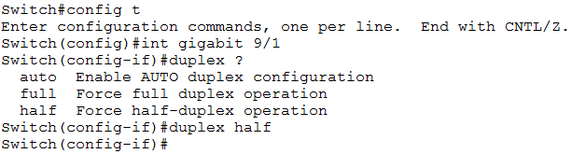

- Now run the show interfaces command to see the updated speed on the port

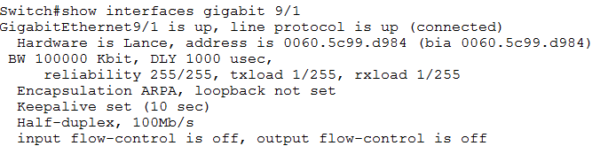

Note: you can run the show interface status command which details all the ports with their negotiated speed and duplex.
The command will display the port number, description, connection status, VLAN, duplex, speed and interface type.

- We will finally set the speed and duplex back to auto-negotiate by using the following commands.
Make sure you specify the interface first.

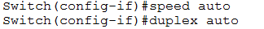

Part B: Troubleshooting Switch Interfaces

- Look at following image and the result after running the show interfaces FastEthernet 0/2 command.

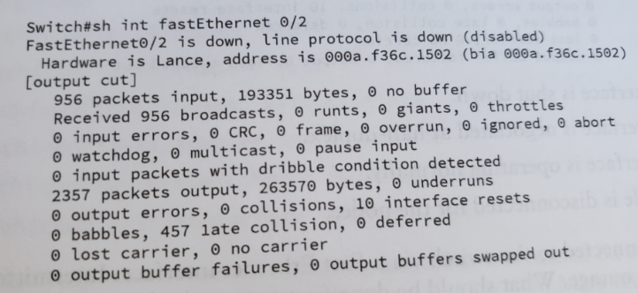

We can see that interface is “disabled”, so would be the most probable cause?

Duplex mismatch would be the probable as there are a large number of late collisions (457 as per the image).
One end of the connect would be set to full duplex while the other end of the connection is set to half-duplex.
Interface is not “shut down” as the state would then read “administratively disabled”.

- Look at following image and the result after running the show interfaces FastEthernet 0/2 command.
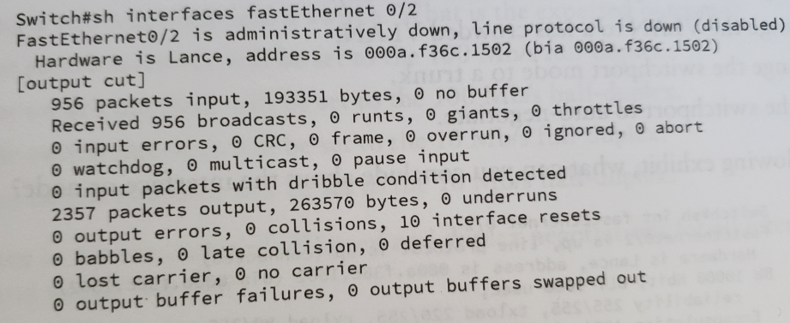

We can see that interface is “administratively down”, which means that the interface has been placed into shutdown state.
To resolve this problem, run the no shut command on the interface.

- Look at following image and the result after running the show interface FastEthernet 0/1 command.

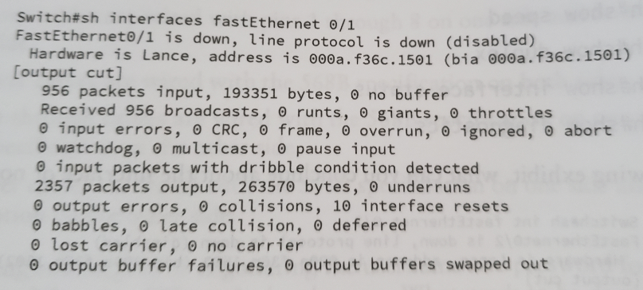

The counters are all normal (no extreme values) but the interface and line protocol are down/down.
Disconnected cable would be the probable cause.

